**SRS Document for Bookstore**

**1. Introduction**

* **Purpose**: The document outlines the requirements for a comprehensive bookstore management system aimed at streamlining inventory, sales, and customer interactions.
* **Scope**: The system will cover all aspects of bookstore operations, from inventory management to user interactions and administrative control.
* **Objectives**: Improve efficiency, enhance user experience, and increase sales through effective management and customer engagement.
* **Target Audience**: Developers, stakeholders, management, and anyone involved in the system's design, development, or usage.

**2. System Overview**

* **Description**: The bookstore management system will be an online platform facilitating book browsing, purchase, order management, and administrative controls.
* **Features**:
  + User authentication and authorization.
  + Catalog management with detailed book information.
  + Order processing, tracking, and payment integration.
* **Interfaces**: The system will have interfaces with payment gateways and book information databases.

**3. Functional Requirements**

3.1. User Management

* **Roles and Permissions**:
  + Admin: Full control over inventory, users, and system settings.
  + Customer: Access to browsing, purchasing, and account management.
* **User Registration and Authentication**:
  + Registration with valid email, password.
* **Profile Management**:
  + Edit profile.

3.2. Inventory Management

* **Book Management**:
  + Add, edit, delete books with attributes (title, author, genre, ISBN).
  + Batch import/export for bulk inventory management.

3.3. Order Management

* **Shopping Cart and Checkout**:
  + Add items to cart, modify quantities.
  + Secure checkout process with multiple payment options (credit/debit cards, PayPal, etc.).
* **Order Tracking and History**:
  + View order invoices.

3.4. Admin Panel

* **Dashboard**:
  + Overview of sales, orders, and inventory.
  + Quick access to critical functionalities and reports.
* **User and Staff Management**:
  + Add/edit/delete users and staff accounts.

3.5. Customer Interaction

* **Reviews and Ratings**:
  + Users can rate and review books.
  + Display average ratings and reviews on book pages.

**4. Non-Functional Requirements**

* **Performance**:
  + Response time: Page loads within 3 seconds.
  + Scalability: Handles concurrent users during peak times.
* **Security**:
  + Data encryption (SSL) for secure transactions.
  + Regular backups and disaster recovery plan.
* **Reliability**:
  + System uptime of at least 99%.
  + Error handling and logging mechanisms.
* **Usability**:
  + Intuitive and responsive UI/UX design.
  + Accessibility features for users with disabilities.
* **Compatibility**:
  + Compatibility across major browsers and devices.
  + Responsive design for mobile devices.
* **Regulatory Compliance**:
  + Compliance with GDPR, data protection laws, and PCI DSS standards.

**5. System Models**

* **Use Case Diagram**:

* ERD: 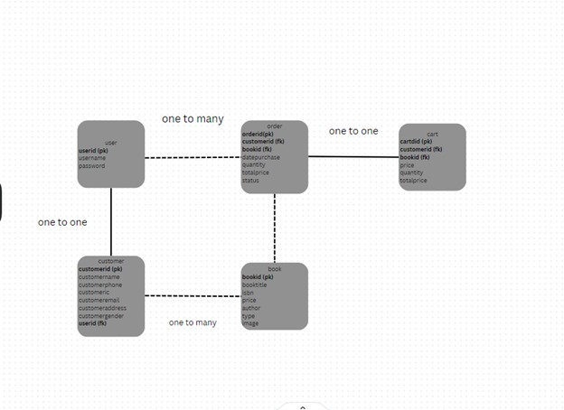

**6. External Interface Requirements**

* **Book Information Sources**:
  + APIs or databases for accessing book details and metadata.

**7. Other Requirements**

* **Documentation**:
  + Comprehensive user manuals, system guides.
* **Training**:
  + Training materials for staff on system usage and management.
* **Testing**:
  + Test scenarios, cases, and plans for functional and non-functional aspects.
* **Maintenance**:
  + Plans for regular updates, bug fixes, and customer support.